**Research**

***Wind speed influence***

*Energy Grid North*

|  |
| --- |
| **Datum : 9 mrt. 2021** |
| **Versie : 1** |
| **Status : Start** |
| **Auteur : Aydin, F.** |

# Introduction

The aim of this research is to gather information about the influence of wind on wind energy. A wind turbine, or wind energy converter, is a device that converts the wind's kinetic energy into electrical energy. Wind speed and wind force play a major role in the generation of energy.

**Introduction** **2**

**Questions and methods** **3**

**Which factors have influence on a Wind turbines power output?** **4**

**When won’t the wind turbines generate?** **4**

**How to calculate from wind speed to electrical energy?** **6**

**How many wind turbines are there in the northern region?** **7**

**Conclusion** **8**

**Appendix** **9**

# Questions and methods

Main question: **How does wind influence the amount of generated wind energy?**

Sub questions:

* **Which factors have influence on a Wind turbines power output?**
* **When won’t the wind turbines generate?**
* **How to calculate from wind speed to electrical energy?**
* **How many wind turbines are there in the northern region?**

Methods:

* + Library
    - Literature study (read different studies)

# Which factors have influence on a wind turbines power output?

* Wind speed
  + Higher wind speed = more energy.
  + Usually turbines are placed at regions with average wind speed.
  + The limits of the range are known as the cut-in speed and cut-out speed.
    - The cut-in speed is the point at which the wind turbine is able to generate power.
    - The cut-out speed is the point at which the turbine must be shut down to avoid damage to the equipment.
* Air density
  + Dense air exerts more pressure on the rotors, which results in higher power output.
  + Air density is maximum at sea level.
* Height of turbine
  + At ground level, there are many obstructions in the form of buildings, houses, trees, etc.
  + Doubling the height of the turbine almost doubles wind power output.
* Rotor blade
  + Doubling the rotor diameter will quadruple the energy output.
  + A bigger rotor generates more power. Although it may cost more.

# When won’t the wind turbines generate?

There are several reasons to stop a wind turbine.

* Not enough wind

The wind turbine will start spinning at about a wind speed of 2.68 m/s. This is called the cut-in speed.

* Too much wind

At about 29.0576 m/s the cut-out speed will be reached.

* Maintenance / repair

Maintenance and routine repairs require wind turbines to be shut down.

* Reached the demand

When production exceeds demand, turbine operation is limited to avoid large transmission blocks.

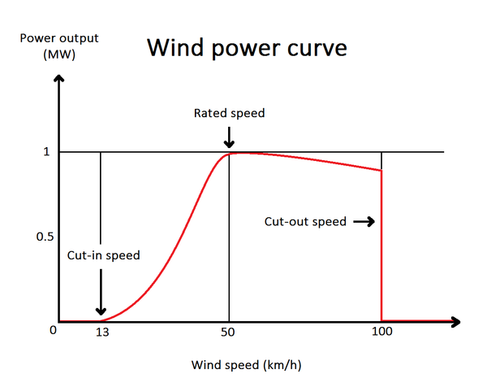

# How to calculate from wind speed to electrical energy?

The formula for the electric power is P = π/2 * r² * v³ * ρ * η

* P = power (W)
* r = Turbine radius
* ρ = density of air (kg/m3)
* v = wind speed (m/s)
* π = 3.14....
* η = Efficiency factor

Example: an offshore wind turbine with a radius of 80 meters at a wind speed of 15 meters per second has a power of 16.3 megawatts, if air density is 1.2 kg/m³ and Efficiency factor is 40%.

A converter tool: <https://rechneronline.de/wind-power/>

Literature: <https://www.raeng.org.uk/publications/other/23-wind-turbine>

# **How many wind turbines are there in the northern region?**

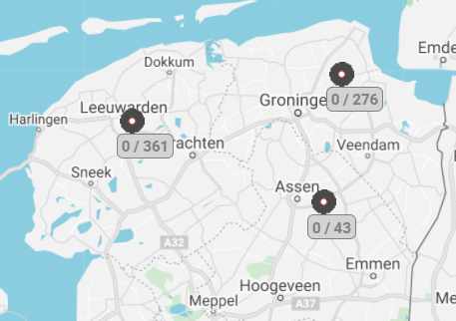

|  |  |
| --- | --- |
| Province | Amount windturbines |
| Friesland | 295 |
| Groningen | 225 |
| Drenthe | 43 |
| Total | 563 |

Source: <https://www.windstats.nl/statistieken/>

# 

# Conclusion

**How does wind influence the amount of generated wind energy?**

The energy generation of wind turbines depend on a number of factors:

* Wind speed
* Air density
* Height of turbine
* Rotor blade size
* Demand
* Maintenance

Too much wind carries risks. This can destroy parts of the wind turbines. Therefore it is recommended to stop them at a wind speed of 29.0576 m/s

The rotor blades do turn with too little wind, but this does not generate any energy. That is why it is also recommended to stop the wind turbines here.

# Appendix

Beurskens, H. J. M., & Brand, A. J. (2013, februari). Wind Energy. Wind energy. <https://publications.tno.nl/publication/34627943/816eUK/b13001.pdf>

Clayton, D. (2020, 9 september). Why Do Wind Turbines Stop? Reasons Explained. Energy Follower. <https://energyfollower.com/why-do-wind-turbines-stop/>

Editor. (2018, 19 maart). How To Calculate Power Output Of Wind | Windpower Engineering. Windpower Engineering & Development. <https://www.windpowerengineering.com/calculate-wind-power-output/>

Lee, K. (2020, 9 november). How Much Power Does a Wind Turbine Generate? Sciencing. https://sciencing.com/much-power-wind-turbine-generate-6917667.html

Office of Energy Efficiency & Renewable Energy. (2017, 20 september). How Do Wind Turbines Survive Severe Storms? Energy.gov. <https://www.energy.gov/eere/articles/how-do-wind-turbines-survive-severe-storms#:%7E:text=When%20the%20anemometer%20registers%20wind,turbine%20to%20automatically%20shut%20off>.

Wikipedia contributors. (2021, 12 maart). Wind turbine. Wikipedia. <https://en.wikipedia.org/wiki/Wind_turbine>